

VERTICAL DIFFUSION PM PROCEDURE (POCL3)
PM Type: BPM Prepared by:
Machine: POCL3 Robin 羅彬森
PM Frequency: every 200 & 400-450 run S200 FURNACE
Date: May 2017


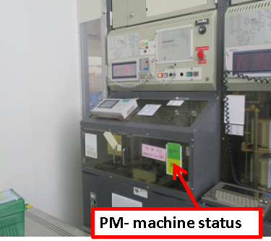 |  |  |  | 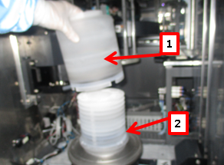
1. Confirm if machine ready for PM, Check status |  | 2. Get controller from front of machine, and connect to back terminal on lower right side. |  | 3. Remove pedestal cover, pedestal

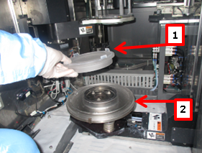 |  |  |  | 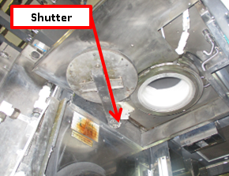
4. Remove Pedestal Base |  | 5. Remove boat |  | 6. Remove back machine cover, and remove shutter and cover

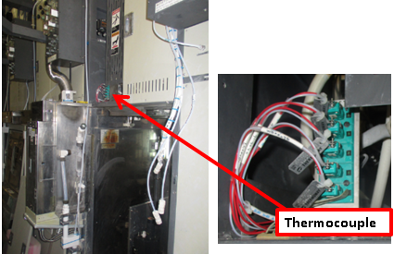 |  | 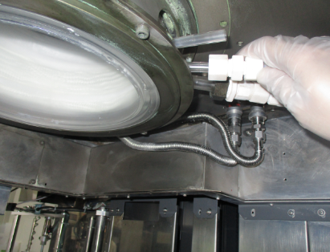 |  | 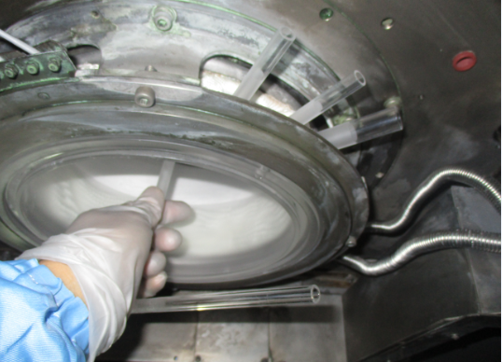
7. Remove upper cover and disconnect TC connector |  | 8. Remove Gas IN hose connection |  | 9. remove Injector

Doc. #: 2017-CRP-008 rev.00 Page 1 of 4

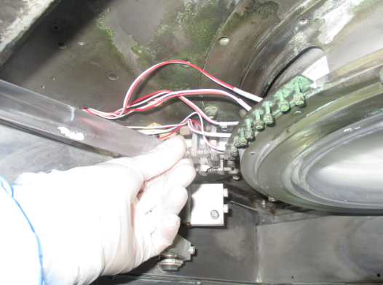 |  | 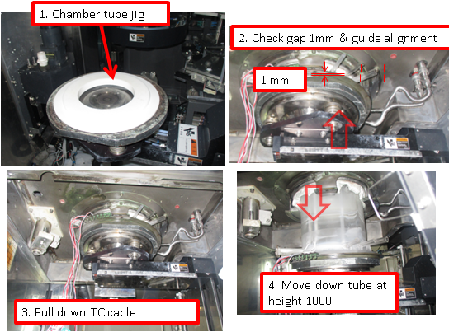 |  | 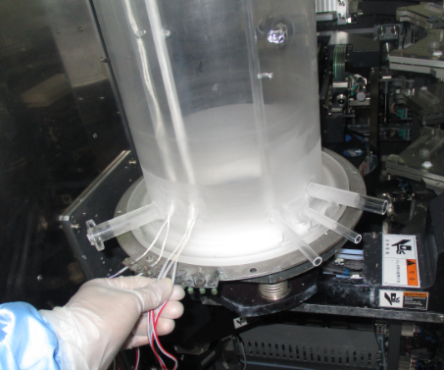
10. remove gas exhaust pipe |  | 11. Using jig unlock inner tube and bring down at M01 height=1000 |  | 12. remove TC at and bring down chamber tube TC (4,5) + (1,2,3)

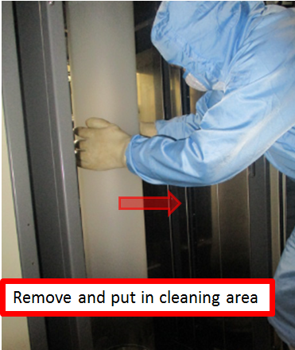 |  | 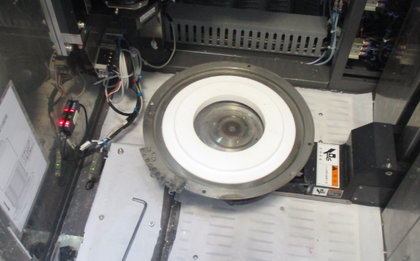 |  | 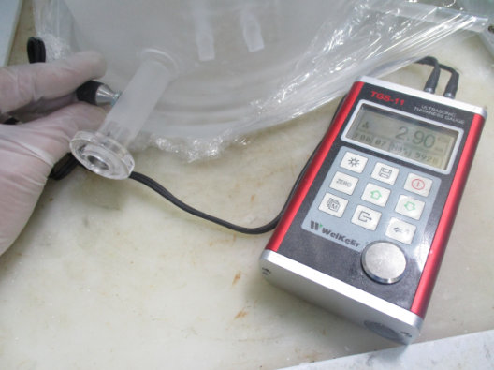
13. Using safety gloves remove chamber tube and bring to cleaning area using push cart. |  | 14.. Clean manifold and Tube lock ring |  | 15. Get new Chamber tube and measure thickness of exhaust pipe >2.5

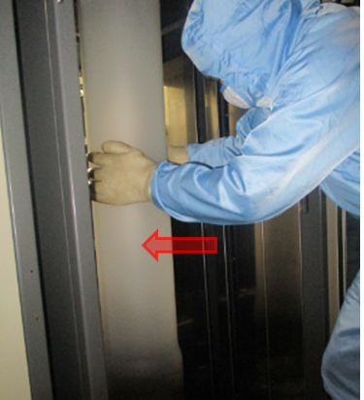 |  |  |  | 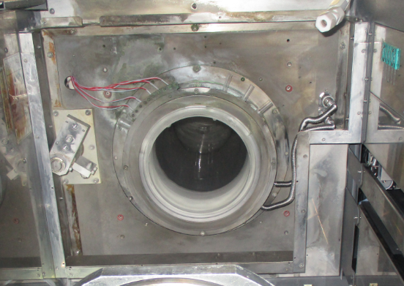
16. Install chamber tube |  | 17. Move elevator up at Ht.1000 and install TC (4,5) + (1,2,3) |  | 18. Move elevator up and lock Chamber tube and connect heater. Then bring down lifter to P01.

 |  |  |  | 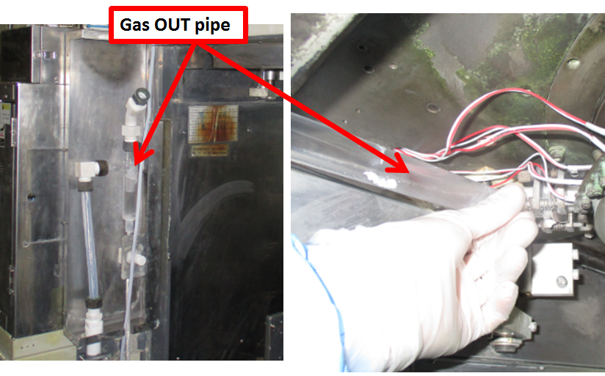
19. Install Injector |  | 20. connect gas Input hose |  | 21. Clean exhaust hose and Install gas exhaust pipe

Doc. #: 2017-CRP-008 rev.00 Page 2 of 4

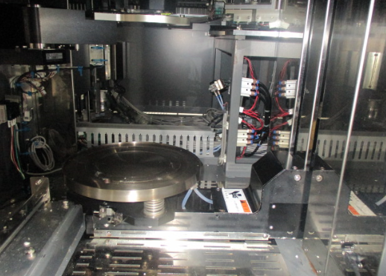 |  | 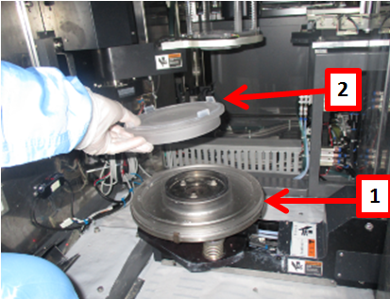 |  | 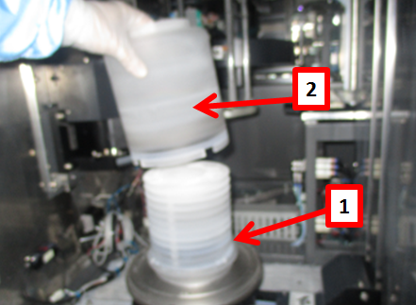
19. Clean chamber cap |  | 20. Install pedestal base |  | 21. Install pedestal and Pedestal cover

 |  |  |  | 
22. Install boat |  | 23. Put M06 in P01, put boat on top of pedestal and check alignment |  | 24. while M02 is in P02, Move M01 between P02 and P05, adjust if top of boat move

 |  |  |  | 
25. Check chamber and boat gap, move boat at Ht.=1000 and rotate360deg |  | 26. Put M02 in P01 to check/adjust boat lock |  | 27. Put boat M02 in P01 to do Transfer check. Load dummy wafer

 |  | 
28. Check/adjust wafer position on boat, and fork gap between wafers |  | 29. Unload dummy wafer and cassette. |  | 30. Install shutter cover, check shutter movement. Move boat inside chamber.

Doc. #: 2017-CRP-008 rev.00 Page 3 of 4

Install cover and ducting exhaust
 |  | EA TEST RUN
43. Clean and Vacuum inside machine and Transfer robot area before close machine |  | 44. fill up machine log book PM OK and endorse to EA for test run

Doc. #: 2017-CRP-008 rev.00 Page 4 of 4

